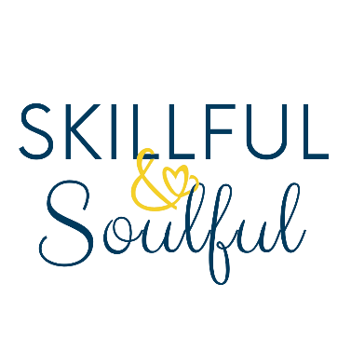

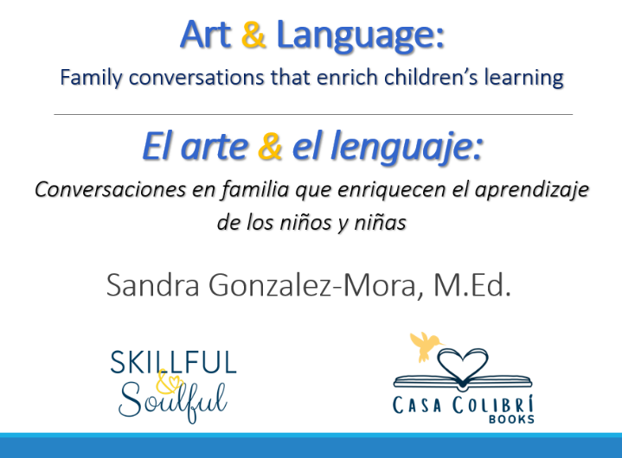

**Overview:** The Art & Language workshop encourages families to use art and books to help spark conversations between parents and children that enrich a child’s life. In addition to promoting language and literacy, Skillful & Soulful Press strives to increase art appreciation among communities of color because we strongly believe that this contributes to the life-changing experiences and conversations that families can have.

**Delivery:** This is a two-part workshop: 1) One-hour lecture on children’s language development through arts integration and exposure to arts culture. We share with parents how visual arts offer opportunities to develop creativity, imagination, and higher order thinking in young children; and 2) A two-hour painting session facilitated by the illustrator of our books, Reynaldo Mora, who leads a step-by-step process where participants create their own art piece on canvas. The images participants paint are inspired by the illustrations of our bilingual children’s books.

**Material:** All the art supplies and material needed for the second part of the workshop are included (16 x 20 canvas, acrylic paint, easels, palettes, brushes, aprons).

**Language**: It is recommended that the workshop be delivered in its entirety in one language, English or Spanish. Simultaneous translation should be offered by the host agency.

**Group Size:** The ideal number for an interactive workshop experience is 20 to 40 adult participants (or students older than 10 years old)

**Cost:** $1,500 for **up to** 20 participants (add $45 per person over 20 participant count to cover art supplies and materials.)

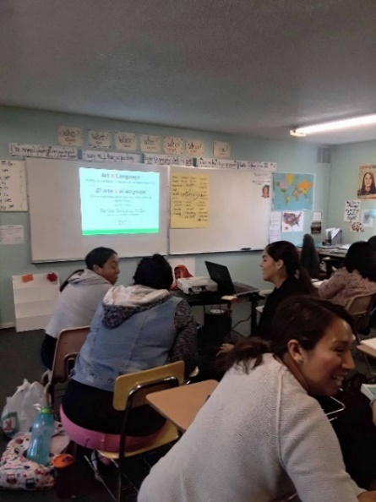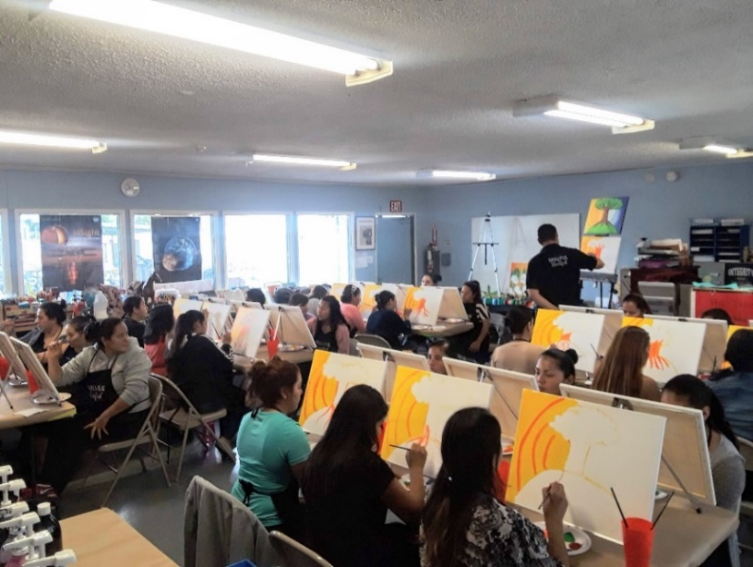

**To schedule, please email Sandra Gonzalez, M.Ed. at** [**skillfulsoulful@gmail.com**](mailto:skillfulsoulful@gmail.com)

**© 2024 by Skillful & Soulful Press. All rights reserved.**